IOT Solar Power Monitoring System

Solar power plants need to be monitored for optimum power output. This helps retrieve efficient power output from power plants while monitoring for faulty solar panels, connections, dust accumulated on panels lowering output and other such issues affecting solar performance. So here we propose an automated IOT based solar power monitoring system that allows for automated solar power monitoring from anywhere over the internet. We use arduino based system to monitor a 10Watt solar panel parameters. Our system constantly monitors the solar panel and transmits the power output to IOT system over the internet. Here we use IOT Gecko to transmit solar power parameters over the internet to IOT Gecko server. It now displays these parameters to the user using an effective GUI and also alerts user when the output falls below specific limits. This makes remotely monitoring of solar plants very easy and ensure best power output.
Block Diagram:
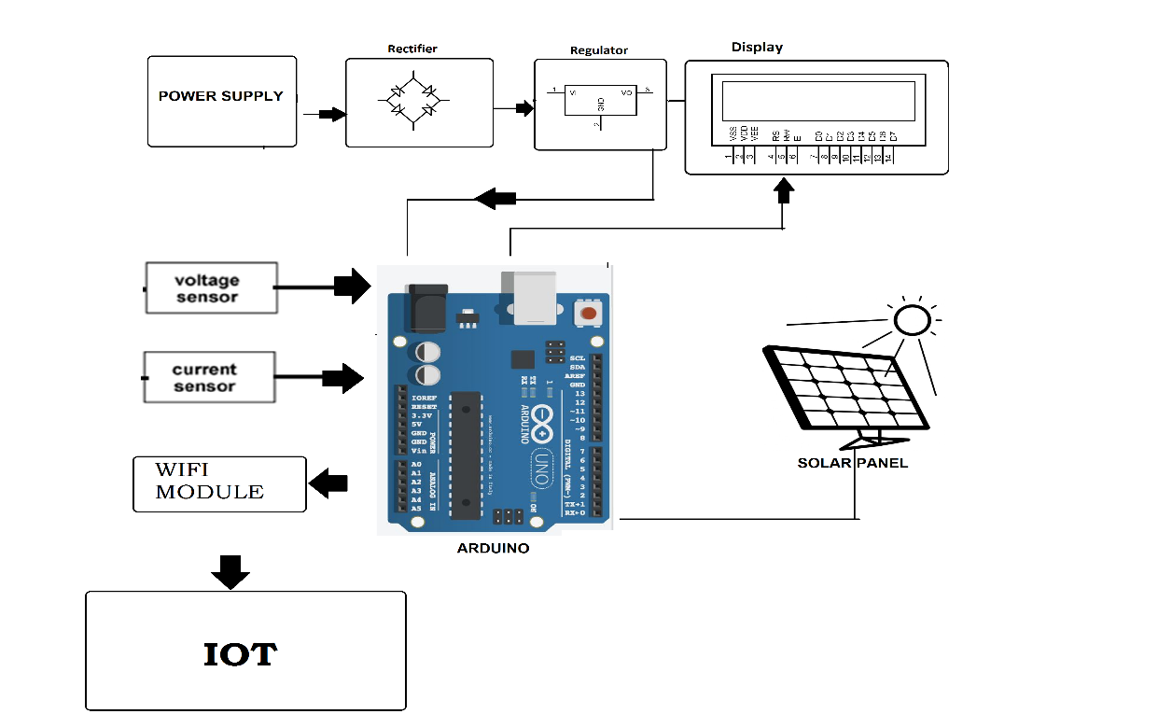

Hardware Specifications :
- Rectifier
- Regulator
- Power Supply
- LCD Display
- Voltage Sensor
- Current Sensor
- Wifi Module
- Arduino Uno
- Solar Panel

Software Specifications :
- Arduino Compiler
- Programming Language: C

